

FAX: (508) 839-9239 EMAIL: sales@GoPrimeTECH.com CALL: (800) 458-5775 VISIT: www.Go PrimeTECH.com

Company: Phone:

Location: Fax :

Contact: Email :

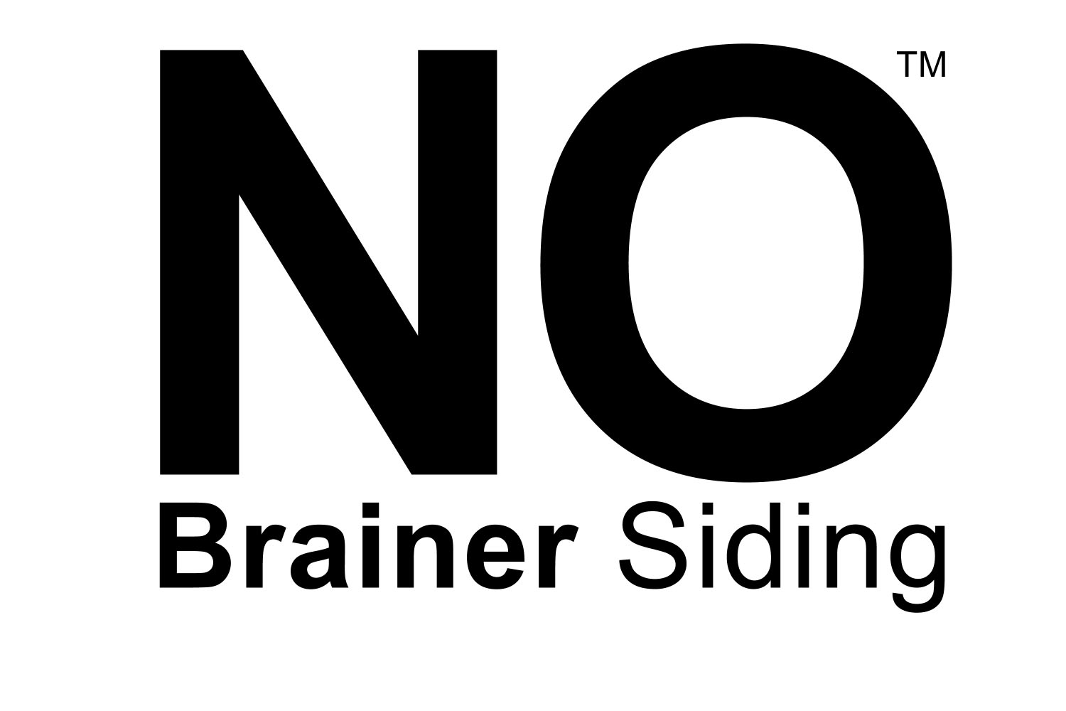
- Delivered to your lumberyard in 10 days or less
- Receive one invoice for siding and coating system
- 1/2 x 6 Clear Vertical Grain (CVG)
- Western Red Cedar Bevel Siding
- Solid (not finger-joined), random length, 3' to 20'
- PrimeTECH™ 650 oil primer and acrylic topcoat
- Highest grade of cedar produced in the world

1. Production Order #: 2. Date of Order:
3. Lot #: 4. Your Cust. P.O.#:
5. Job Name: 6. Job PO #:

7. Footage: Board Feet Lineal Feet

8. Face: Smooth Rough

9. Color Brand : Cabot S.W. Ben. Moore Other:
Name/# -

TRANSPORTATION LOGISTICS

10. Enter the location we should ship your order too only if it differs from the one previously entered.
Ship To:

CUSTOMER RESPONSIBILITY ON ALL PrimeTECH ORDERS
11. Did you tell your customer?
A field coat is required after installation. Light colors may require two field for aesthetic satisfaction.
PrimeTECH is not responsible for defective products once they are installed. Call us if there are defects.
The product must be kept dry and above ground at all times before installation.
Do not install product over a wet substrate (above 15% moisture content).
There is no guarantee of any kind against tannin staining. Pre-priming ensures a long-lasting coating; it does not prevent tannin staining.

Signature

PrimeTECH is a registered trademark of Churchill Coatings Corporation. (800) 458-5775

