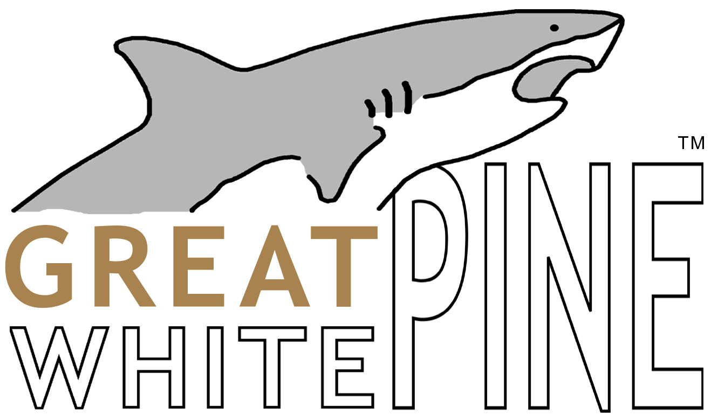

Premium Eastern White Pine with Two Coats of Oil Primer

Featuring:

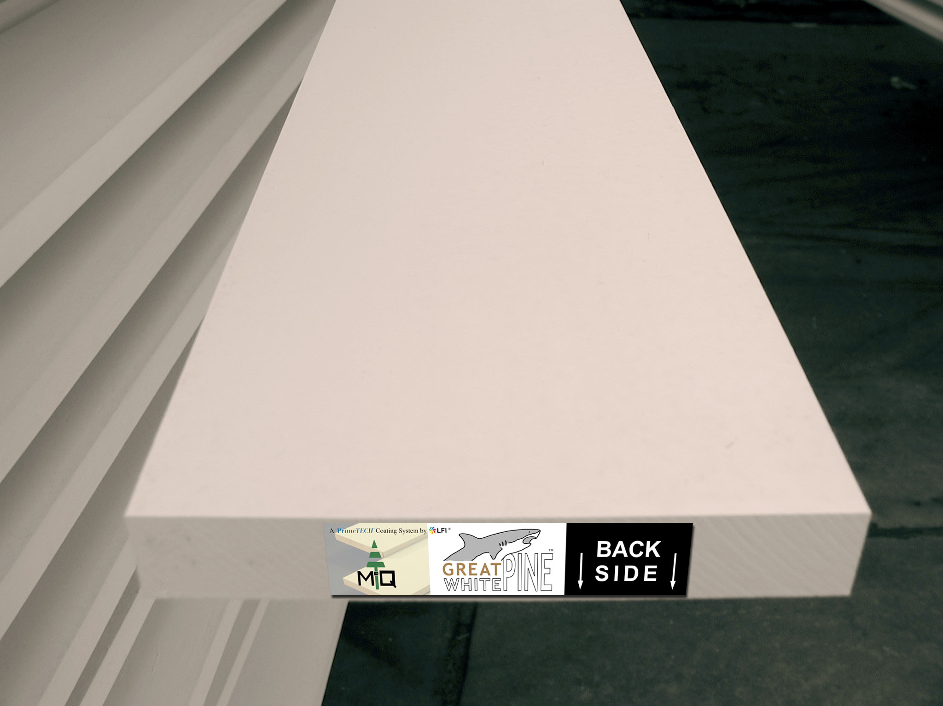
- Durgan & Crowell precision milling

- Historic durability, stability, and availability of authentic Eastern White Pine

- Carefully sealed knots with B.I.N. shellac-based primer

- Two coats of PrimeTECH TitaniumWhite™ oil-based primer

- Individually end-tagged boards for easy product identification and differentiation

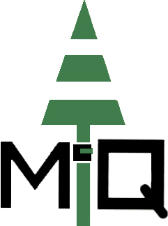
McQuesten Company, Inc.

Visit us at: www.GoPrimeTECH.com
Or Call Toll Free: 800-458-5775

