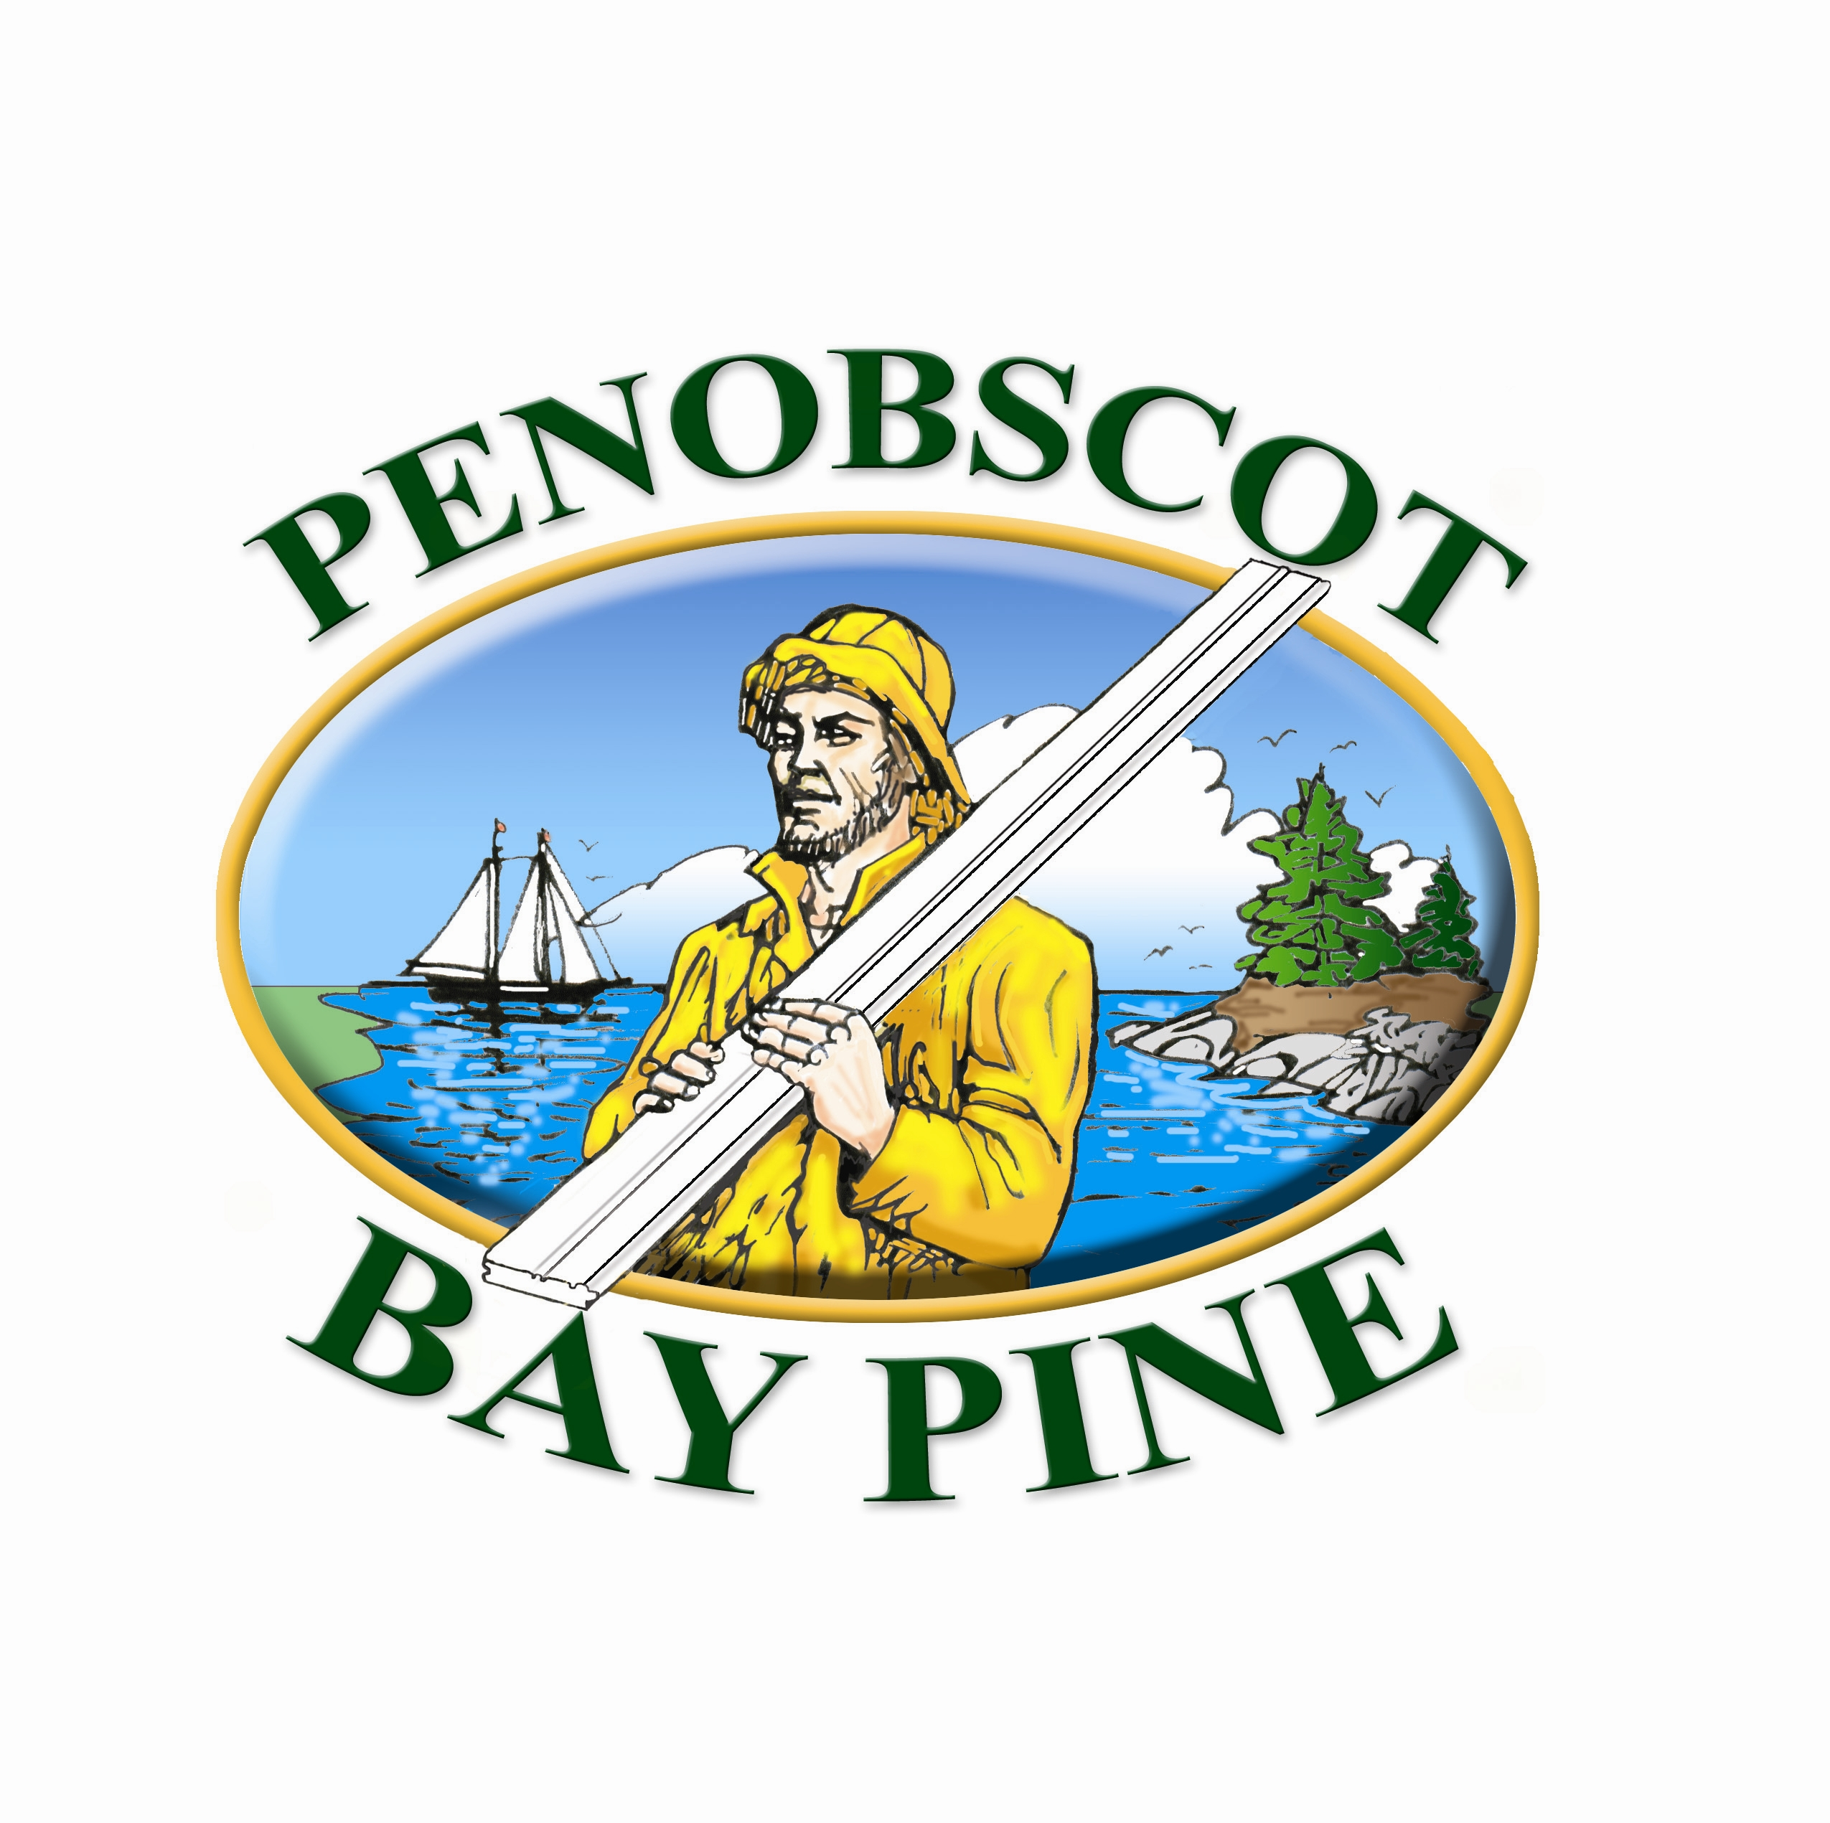


Penobscot Bay Pine Boards

Made In Maine SFI® Green Certified

- Robbins Premium Eastern White Pine
- Factory Finished by Churchill Coatings of Maine
- One coat of Cabot® Harbormaster™ Satin Polyurethane
- Excellent U. V. Protection
- Interior or Exterior Use
- Can be top coated with a variety of interior or exterior coatings from Cabot®

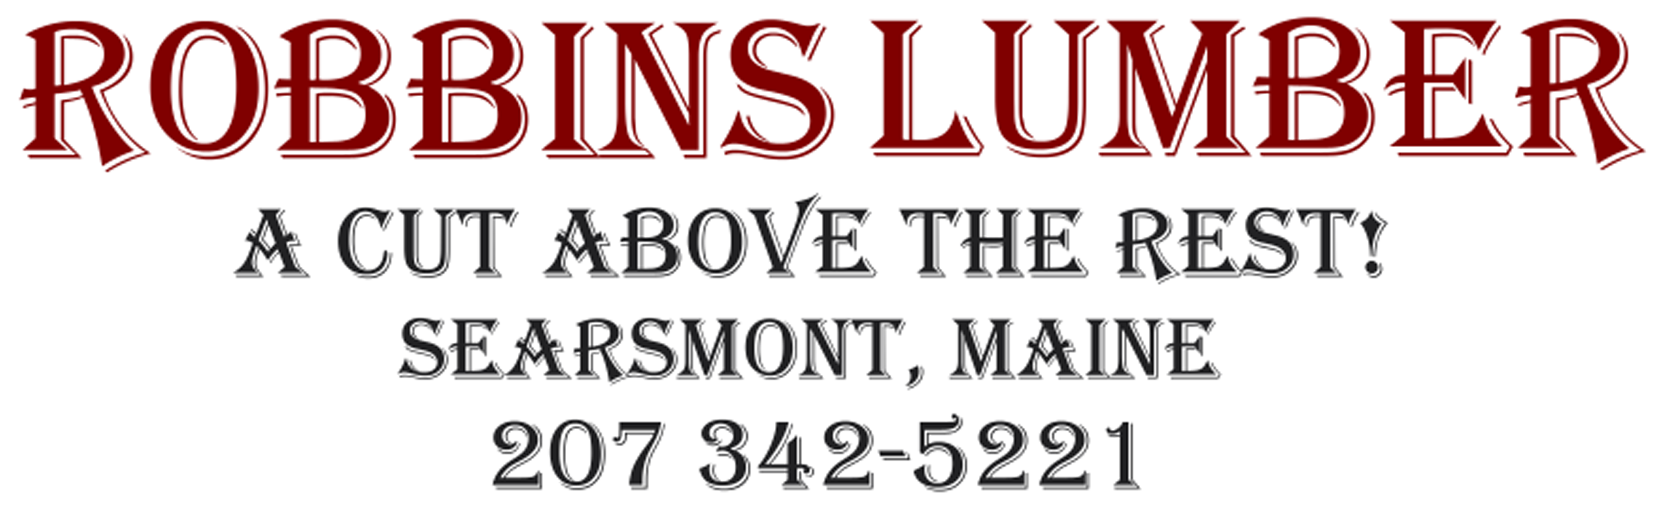

Visit us at: www.GoPrimeTECH.com
Or Call: 800-458-5775

