TM
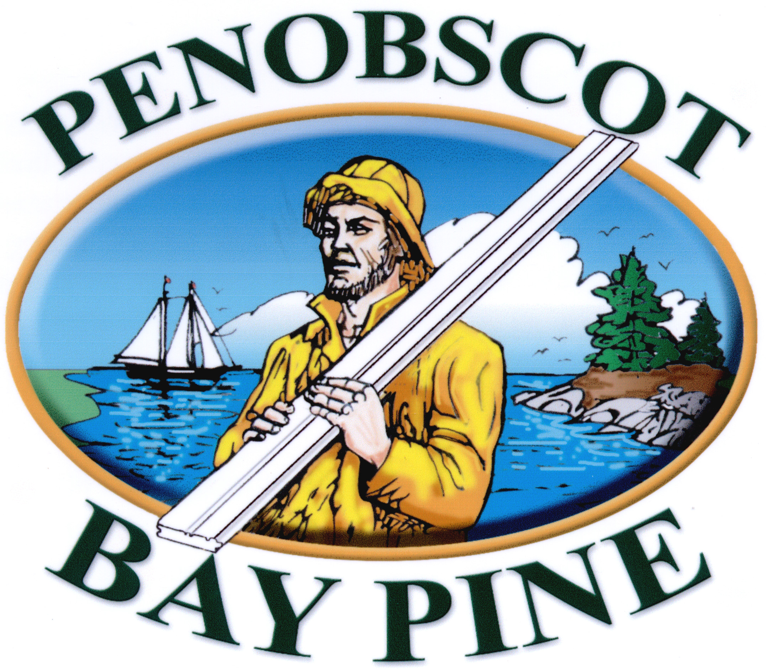

TM

Penobscot Bay Pine Clapboard Siding

- Robbins Finger-Joined Eastern White Pine Bevel Siding
- Locally Available
- All 16’ Lengths – Saves Time
- No knots to bleed
- Factory Finished by Churchill Coatings of Maine
- One coat of PrimeTECH PremiumHide® Oil Primer made by Cabot®
- Use either smooth or rough face exposure
- Unique joint nearly invisible on both rough and smooth face
- Topcoat with exterior coatings from Cabot® for long term warranties

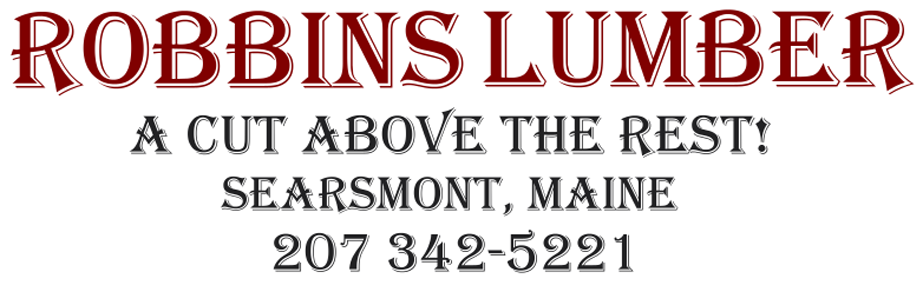

Visit us at: www.GoPrimeTECH.com
Or Call: 800-458-5775

