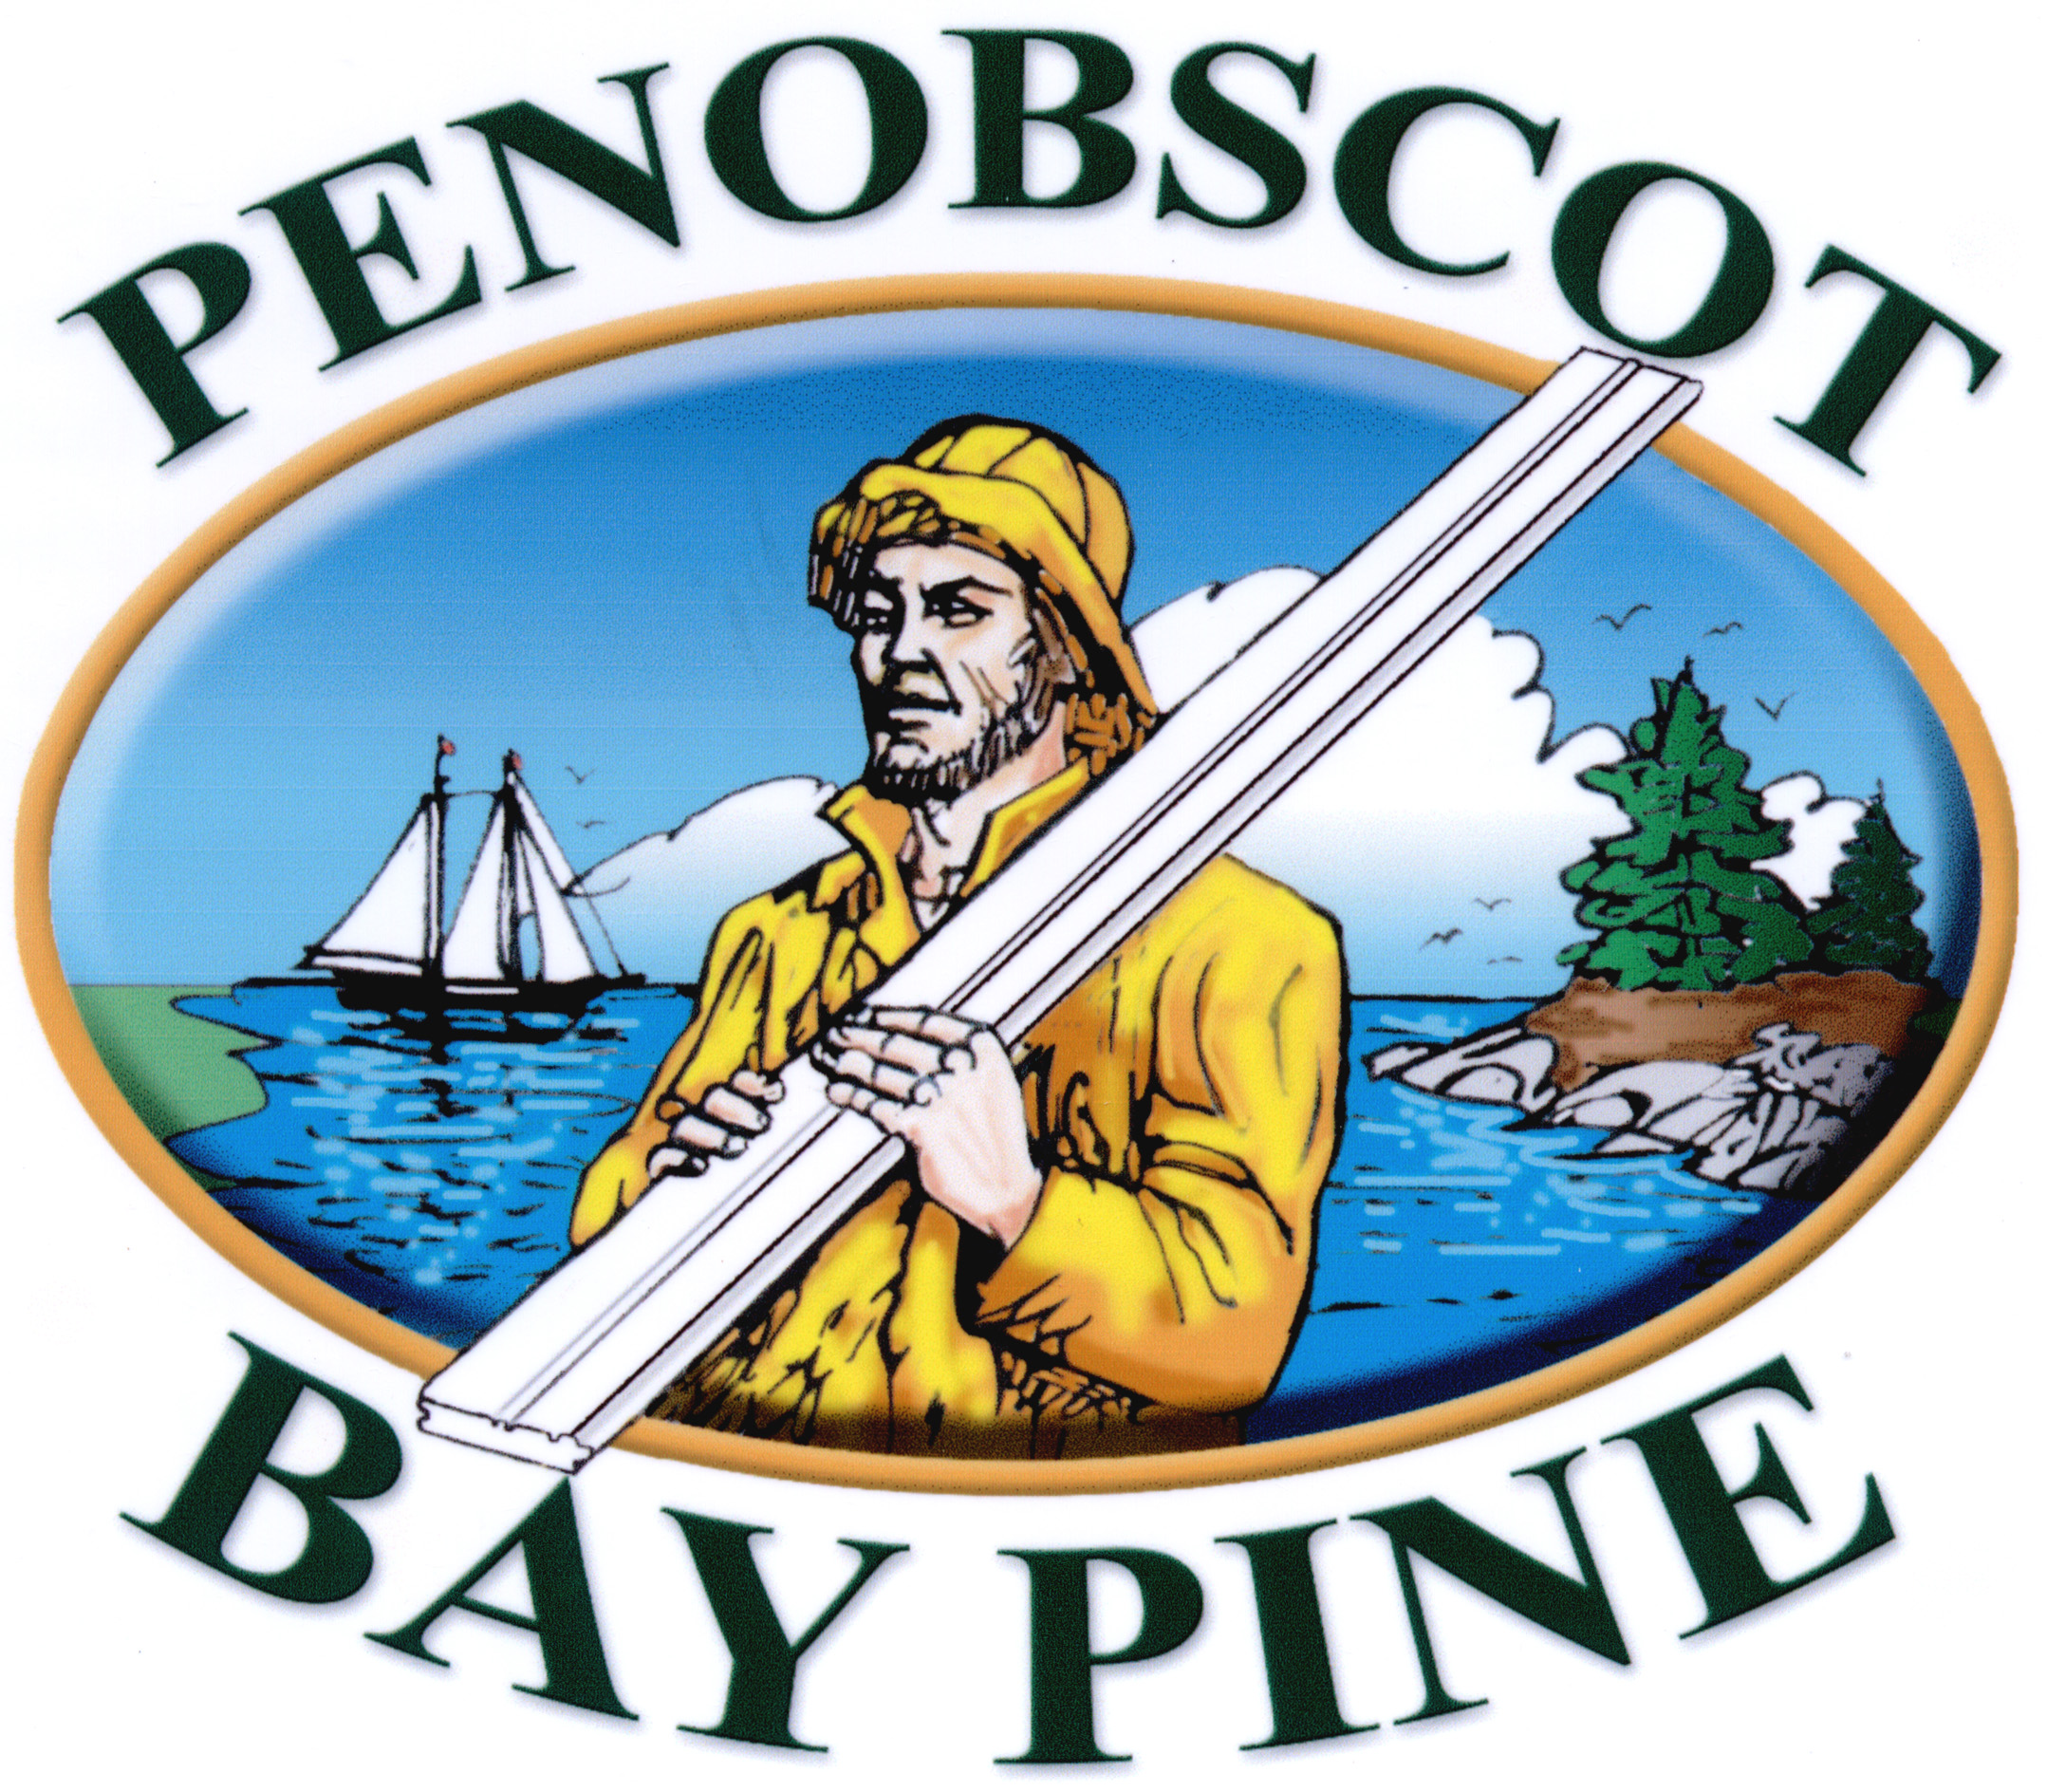
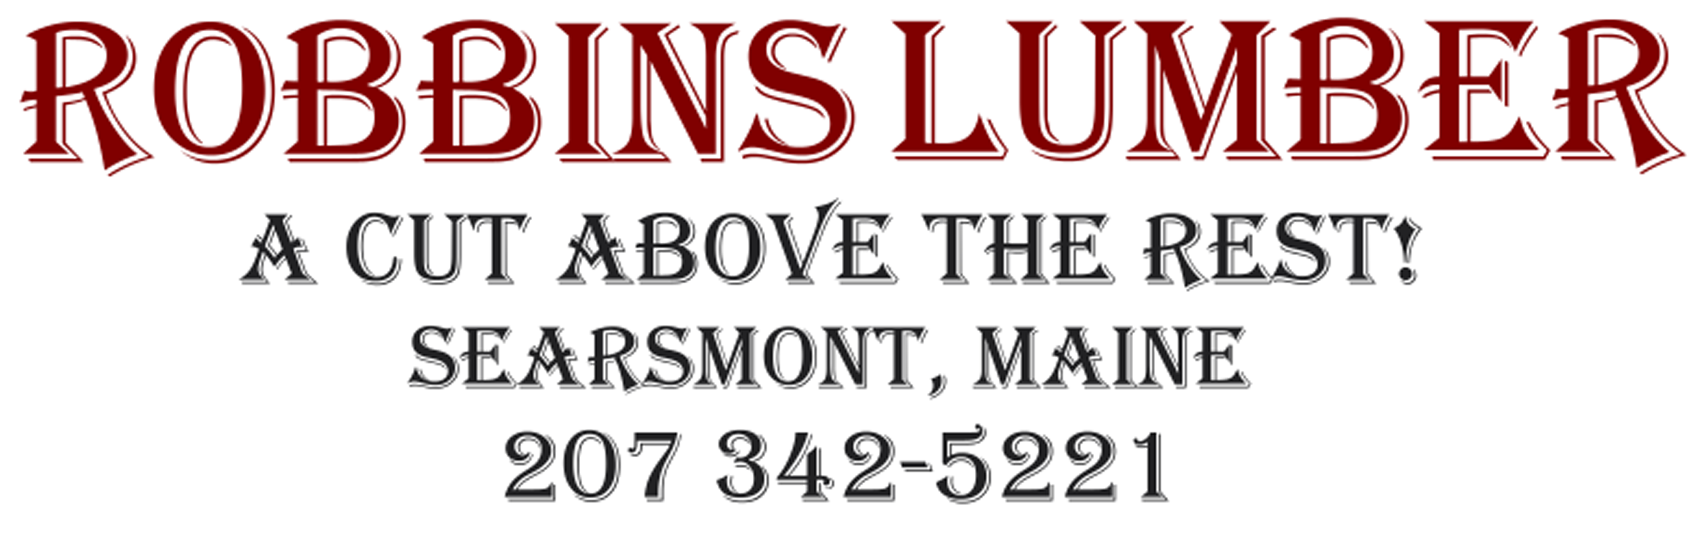
PinePack™
Custom House Trim

Custom Colored Trim Orders
Delivered in 10 Days.

PinePack™ Features:

 100% Clear Eastern White Pine

 Precision Milling in Maine by Robbins
Lumber Mill

 Finger-Jointed Square Trim in 4/4" & 5/4"
3" through 12" widths

 All 16' Lengths For Easy Handling

 PrimeTECH Coating systems by Churchill
Coatings of Maine

 2-Coats, Tinted Oil Primer & Cabot Latex
Topcoat

 15 year Coating warranty after only 1 Field
Coat of Cabot The Finish™

 Available in ANY Manufacturers Color.
We use Cabot Stains

Visit us at: www.GoPrimetech.com
Or Call: (800) 458-5775

