
Visit us at: www.GoPrimeTECH.com
Or Call: 800-458-5775

Direct from Churchill Coatings to your Lumberyard

In Partnership with

5 ¼ and 6 ¼ Cedarmill© or Smooth - James Hardie® Cement Siding

Unique Product Features

• Order siding and coating system from Churchill.
Receive one bill for siding and coating system from
Churchill Coatings.

• James Hardie brand cement siding.

• Siding in warehouses at Churchill Coatings.

• Featuring Cabot® C³ with Teflon® Surface Protector by Dupont, with 20-Year coating warranty from Cabot after completing the required field coat.

• Delivered within ten business days directly to you from Churchill Coatings.

• Available in any color.

Delivered

In 10 Days

Specifics

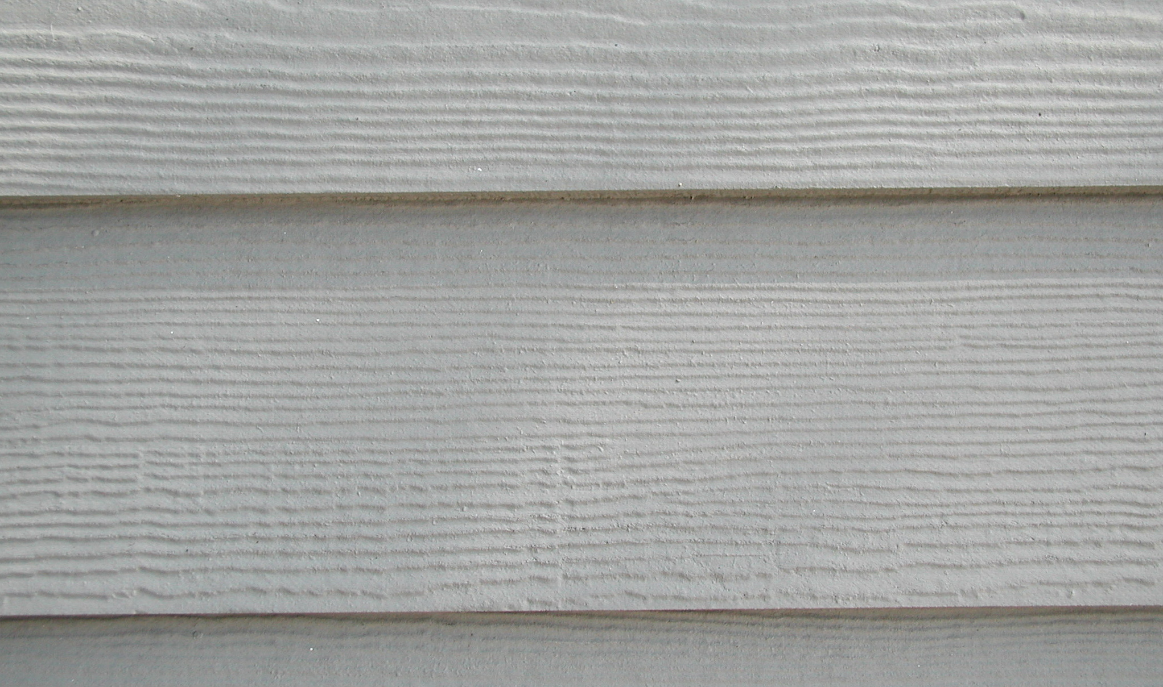

Hardiplank®
• PatriotPlank™
One Coat C³ Cabot® Cement Coat
Any Color
Final coating required after installation

• Substrates Available
5¼” & 6 ¼” Smooth and Cedarmill©
*Other James Hardie Products available within 2-3 weeks

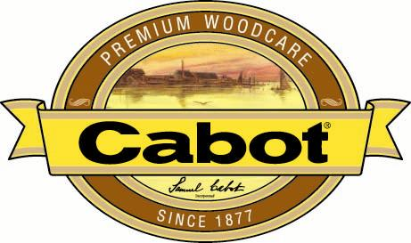
James Hardie and Hardiplank are trademarks owned by James Hardie Research Pty Limited Can 066 114 092

Visit us at: www.GoPrimeTECH.com
Or Call: 800-458-5775

Direct from Churchill Coatings to your Lumberyard
In Partnership with

5 ¼ and 6 ¼ Cedarmill© only - James Hardie® Cement Siding

Unique Product Features
• Order siding and coating system from Churchill. Receive one bill for siding and coating system from Churchill Coatings.

• James Hardie brand cement siding.

• Siding in warehouse at Churchill Coatings.

• Featuring Cabot C³ Woodtones™ for Cement Siding for the look of a semi-transparent stain

• Delivered within ten business days directly to you from Churchill Coatings

• Available in Cedar, Redwood, Mahogany, Maple, and Driftwood (See Color Card)

Delivered

In 10 days

Specifics

• PatriotPlank™ Stain Collection
Cabot C³-Woodtones™

• Colors
Cedar, Redwood, Maple, Mahogany, and Driftwood (See color Card)

• Substrates Available
Cedarmill©l face only; 5 ¼” & 6 ¼”
*Other James Hardie Cedarmill©l
products available within 2-3 weeks

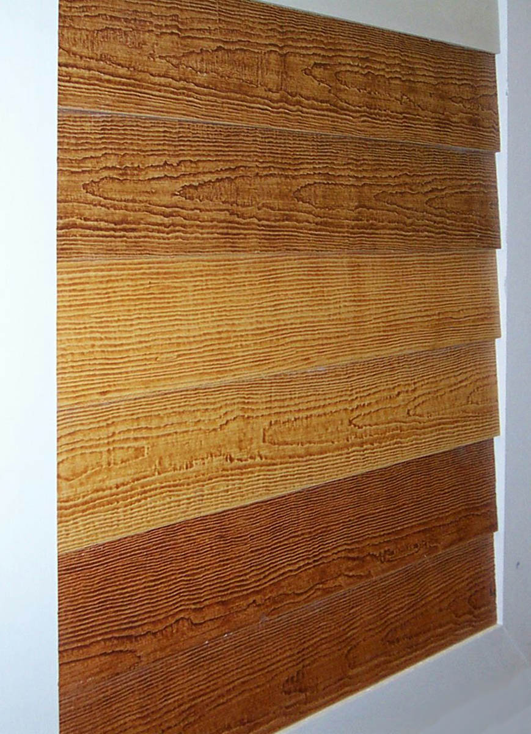
CEDAR

Hardiplank®

MAPLE

REDWOOD
James Hardie and Hardiplank are trademarks owned by James Hardie Research Pty Limited Can 066 114 092

- 2 Full Coats all 4 Sides
- Exceptional square-edge trim boards with bright white primer – 2 coats
- Proven addition to Patriot Pine® one coat system meeting the demands of customers who want extra protection
- Only one additional field coat required for 15-year warranty
- Oil-based coatings for smooth finish and solid appearance
- The most beautiful bright white oil-based primer available
- Easy name recognition
- Backed by Boise’s commitment to quality and service
- Solid steady growth of program ensures long-term availability
- All 16-foot lengths
- 1,000 foot units for more cost effective inventory
- Premium-grade universal primer allows for any type of topcoat—latex or oil-based

- 2 Full Coats all 4 Sides
- Exceptional square-edge trim boards with bright white primer – 2 coats
- Proven addition to Patriot Pine® one coat system meeting the demands of customers who want extra protection
- Only one additional field coat required for 15-year warranty
- Oil-based coatings for smooth finish and solid appearance
- The most beautiful bright white oil-based primer available
- Easy name recognition
- Backed by Boise’s commitment to quality and service
- Solid steady growth of program ensures long-term availability
- All 16-foot lengths
- 1,000 foot units for more cost effective inventory
- Premium-grade universal primer allows for any type of topcoat—latex or oil-based

